DEVOIRS 2
Passé Composé

NOM: __________________________________
L’infinitif du verbe | Passé Composé | Exemple
1. marcher | Marché | J’ai marché
2. jouer | Joué | J’ai joué…
3. porter | Porté | J’ai porté…
4. payer | Payé | J’ai payé…
5. essayer | Essayé | J’ai essayé…
6. voir | Vu | J’ai vu…
Exercices pour se préparer au test de français :
AVOIR

7. savoir | Su | J’ai su…
8. devoir | Du | J’ai dû…
9. être | été | J’ai été …
10. avoir | Eu | J’ai eu…

Marcher, jouer, porter, payer, essayer, voir, savoir, devoir, être, avoir

1
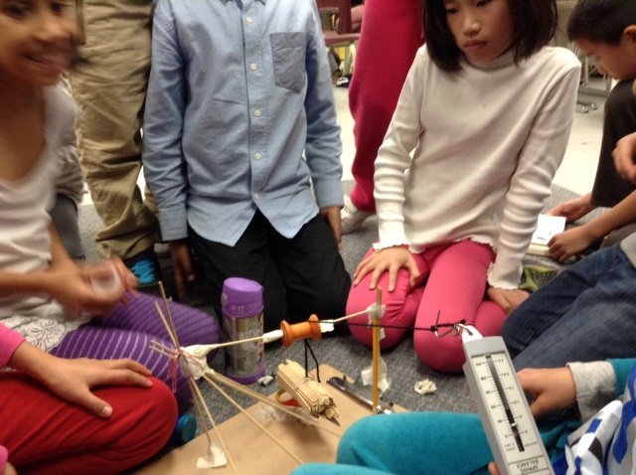
Partie A

Marcher
Je ______________________________________________________________
Tu ______________________________________________________________
Il _______________________________________________________________
Elle _____________________________________________________________
Nous ____________________________________________________________
Vous ____________________________________________________________
Ils ______________________________________________________________
Elles ____________________________________________________________
On _____________________________________________________________
Hannah et Daniel _________________________________________________
Daniel et Kevin ___________________________________________________
Zuhal et Selina ____________________________________________________
Natalie et moi ____________________________________________________

3 phrases :
________________________________________________________________
________________________________________________________________
________________________________________________________________
________________________________________________________________
________________________________________________________________
________________________________________________________________
3

Jouer
Je ______________________________________________________________
Tu ______________________________________________________________
Il _______________________________________________________________
Elle _____________________________________________________________
Nous ____________________________________________________________
Vous ____________________________________________________________
Ils ______________________________________________________________
Elles ____________________________________________________________
On _____________________________________________________________
Hannah et Daniel _________________________________________________
Daniel et Kevin ___________________________________________________
Zuhal et Selina ____________________________________________________
Natalie et moi ____________________________________________________

3 phrases :
________________________________________________________________
________________________________________________________________
________________________________________________________________
________________________________________________________________
________________________________________________________________
________________________________________________________________

4

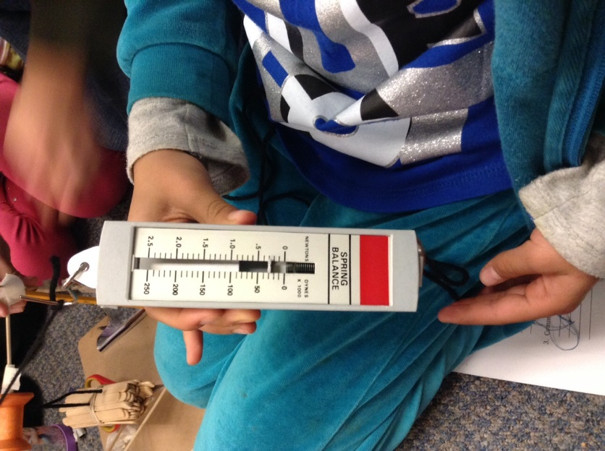
Porter
Je ______________________________________________________________
Tu ______________________________________________________________
Il _______________________________________________________________
Elle _____________________________________________________________
Nous ____________________________________________________________
Vous ____________________________________________________________
Ils ______________________________________________________________
Elles ____________________________________________________________
On _____________________________________________________________
Hannah et Daniel _________________________________________________
Daniel et Kevin ___________________________________________________
Zuhal et Selina ____________________________________________________
Natalie et moi ____________________________________________________

3 phrases :
________________________________________________________________
________________________________________________________________
________________________________________________________________
________________________________________________________________
________________________________________________________________
________________________________________________________________

5

Payer
Je ______________________________________________________________
Tu ______________________________________________________________
Il _______________________________________________________________
Elle _____________________________________________________________
Nous ____________________________________________________________
Vous ____________________________________________________________
Ils ______________________________________________________________
Elles ____________________________________________________________
On _____________________________________________________________
Hannah et Daniel _________________________________________________
Daniel et Kevin ___________________________________________________
Zuhal et Selina ____________________________________________________
Natalie et moi ____________________________________________________

3 phrases :
________________________________________________________________
________________________________________________________________
________________________________________________________________
________________________________________________________________
________________________________________________________________
________________________________________________________________
6

Essayer
Je ______________________________________________________________
Tu ______________________________________________________________
Il _______________________________________________________________
Elle _____________________________________________________________
Nous ____________________________________________________________
Vous ____________________________________________________________
Ils ______________________________________________________________
Elles ____________________________________________________________
On _____________________________________________________________
Hannah et Daniel _________________________________________________
Daniel et Kevin ___________________________________________________
Zuhal et Selina ____________________________________________________
Natalie et moi ____________________________________________________

3 phrases :
________________________________________________________________
________________________________________________________________
________________________________________________________________
________________________________________________________________
________________________________________________________________
________________________________________________________________

7

Voir
Je ______________________________________________________________
Tu ______________________________________________________________
Il _______________________________________________________________
Elle _____________________________________________________________
Nous ____________________________________________________________
Vous ____________________________________________________________
Ils ______________________________________________________________
Elles ____________________________________________________________
On _____________________________________________________________
Hannah et Daniel _________________________________________________
Daniel et Kevin ___________________________________________________
Zuhal et Selina ____________________________________________________
Natalie et moi ____________________________________________________

3 phrases :
________________________________________________________________
________________________________________________________________
________________________________________________________________
________________________________________________________________
________________________________________________________________
________________________________________________________________

8

Savoir
Je ______________________________________________________________
Tu ______________________________________________________________
Il _______________________________________________________________
Elle _____________________________________________________________
Nous ____________________________________________________________
Vous ____________________________________________________________
Ils ______________________________________________________________
Elles ____________________________________________________________
On _____________________________________________________________
Hannah et Daniel _________________________________________________
Daniel et Kevin ___________________________________________________
Zuhal et Selina ____________________________________________________
Natalie et moi ____________________________________________________

3 phrases :
________________________________________________________________
________________________________________________________________
________________________________________________________________
________________________________________________________________
________________________________________________________________
________________________________________________________________

9

Devoir
Je ______________________________________________________________
Tu ______________________________________________________________
Il _______________________________________________________________
Elle _____________________________________________________________
Nous ____________________________________________________________
Vous ____________________________________________________________
Ils ______________________________________________________________
Elles ____________________________________________________________
On _____________________________________________________________
Hannah et Daniel _________________________________________________
Daniel et Kevin ___________________________________________________
Zuhal et Selina ____________________________________________________
Natalie et moi ____________________________________________________

3 phrases :
________________________________________________________________
________________________________________________________________
________________________________________________________________
________________________________________________________________
________________________________________________________________
________________________________________________________________

10

Être
Je ______________________________________________________________
Tu ______________________________________________________________
Il _______________________________________________________________
Elle _____________________________________________________________
Nous ____________________________________________________________
Vous ____________________________________________________________
Ils ______________________________________________________________
Elles ____________________________________________________________
On _____________________________________________________________
Hannah et Daniel _________________________________________________
Daniel et Kevin ___________________________________________________
Zuhal et Selina ____________________________________________________
Natalie et moi ____________________________________________________

3 phrases :
________________________________________________________________
________________________________________________________________
________________________________________________________________
________________________________________________________________
________________________________________________________________
________________________________________________________________

11

Avoir
Je ______________________________________________________________
Tu ______________________________________________________________
Il _______________________________________________________________
Elle _____________________________________________________________
Nous ____________________________________________________________
Vous ____________________________________________________________
Ils ______________________________________________________________
Elles ____________________________________________________________
On _____________________________________________________________
Hannah et Daniel _________________________________________________
Daniel et Kevin ___________________________________________________
Zuhal et Selina ____________________________________________________
Natalie et moi ____________________________________________________

3 phrases :
________________________________________________________________
________________________________________________________________
________________________________________________________________
________________________________________________________________
________________________________________________________________
________________________________________________________________

12

Partie B
L’infinitif du verbe | Passé Composé | 2 Exemples
1. Marcher
2. Jouer
3. Porter
4. Payer
5. Essayer
6. Voir
7. Savoir
8. Devoir
9. être
10. Avoir

13

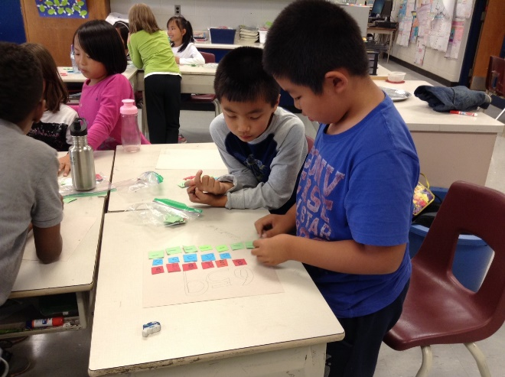
Raconte-moi une histoire
Partie C
Raconter une histoire ! Utiliser les verbes : marcher, jouer, porter, payer, essayer, voir, savoir, devoir, être, avoir

14
Mots croisés !
Créer les mots croisés avec le passe compose de : Marcher, jouer, porter, payer, essayer, voir, savoir, devoir, être, avoir
15
Marcher, jouer, porter, payer, essayer, voir, savoir, devoir, être, avoir
Débrouiller les lettres des mots pour trouver les verbes
chmaré ____________________
ue ____________________
ûd ____________________
éypa ____________________
jéou ____________________
téé ____________________
uv ____________________
us ____________________
sesyaé ____________________
értop ____________________
naHnha a chméar ____________________
lyDan a éjou el ccoser ____________________
rodeTeoh a uv ess mais____________________
bdAi te saJno tno jéuo ____________________
mMe roFst a uv sel vediosr___________________
16

